|  |  |  |
| --- | --- | --- |
| Assembly Process | authors | Cyprien RASANDIMANANA  Damien BESNARD |
| dated | 04/03/2020 |

This assembly test is to discover how assembly the sensor test bench step by step with of pictures.

**Time required:** between 3 and 4 hours

Content

1.1. Tools used and component of the testbench 2

1.1.1. Equipment 2

1.1.2. Tools 2

1.2. Assembly procedure 3

1.3. Arduino card and components 11

1.3.1. Components 11

1.3.2. Connection to Arduino 12

1.3.3. Electrical Assembly 12

1.4. Global illustration 14

## Tools used and component of the testbench

### Equipment

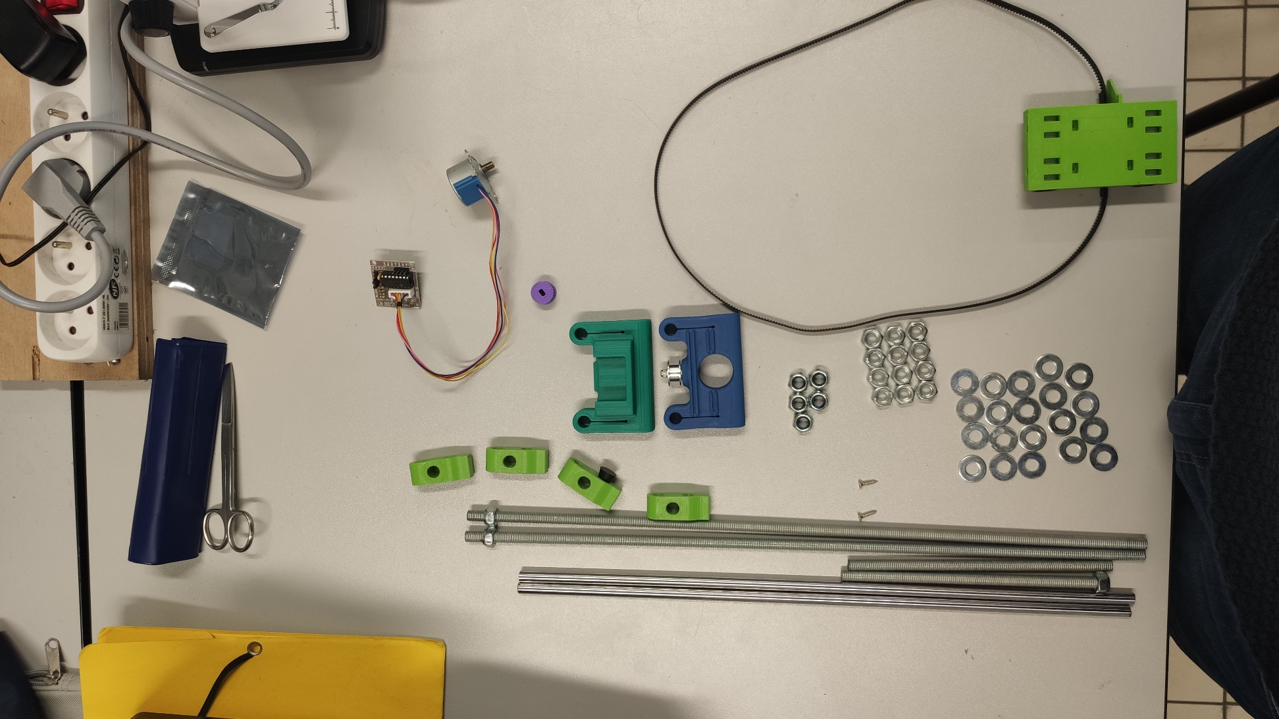

Endless screw 1

Legs 1

notch pulley

Piece1

Piece2

Rails

screws

motor

Leg 2

3

Endless screw 2

Endless screw 4

Endless screw 4

All the components use to assembly.

### Tools

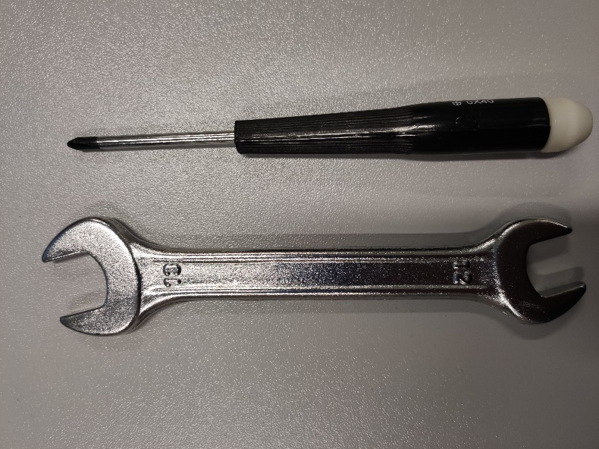

We will use a cross screwdriver a 13th clef.

## Assembly procedure

Step 1

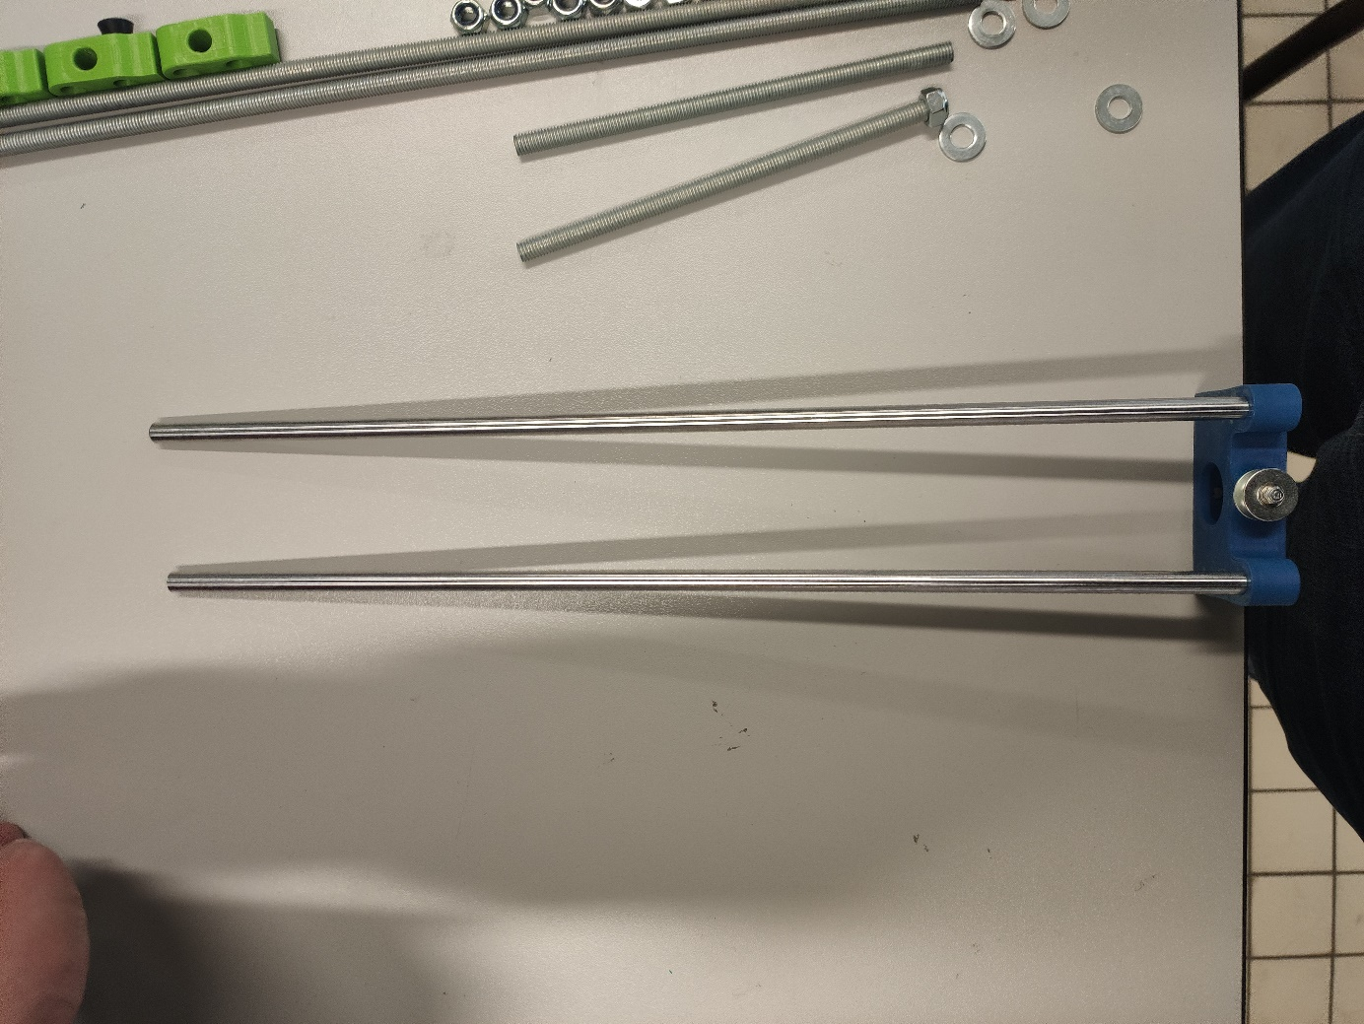

Add the rails in to the piece 2.

Step 2

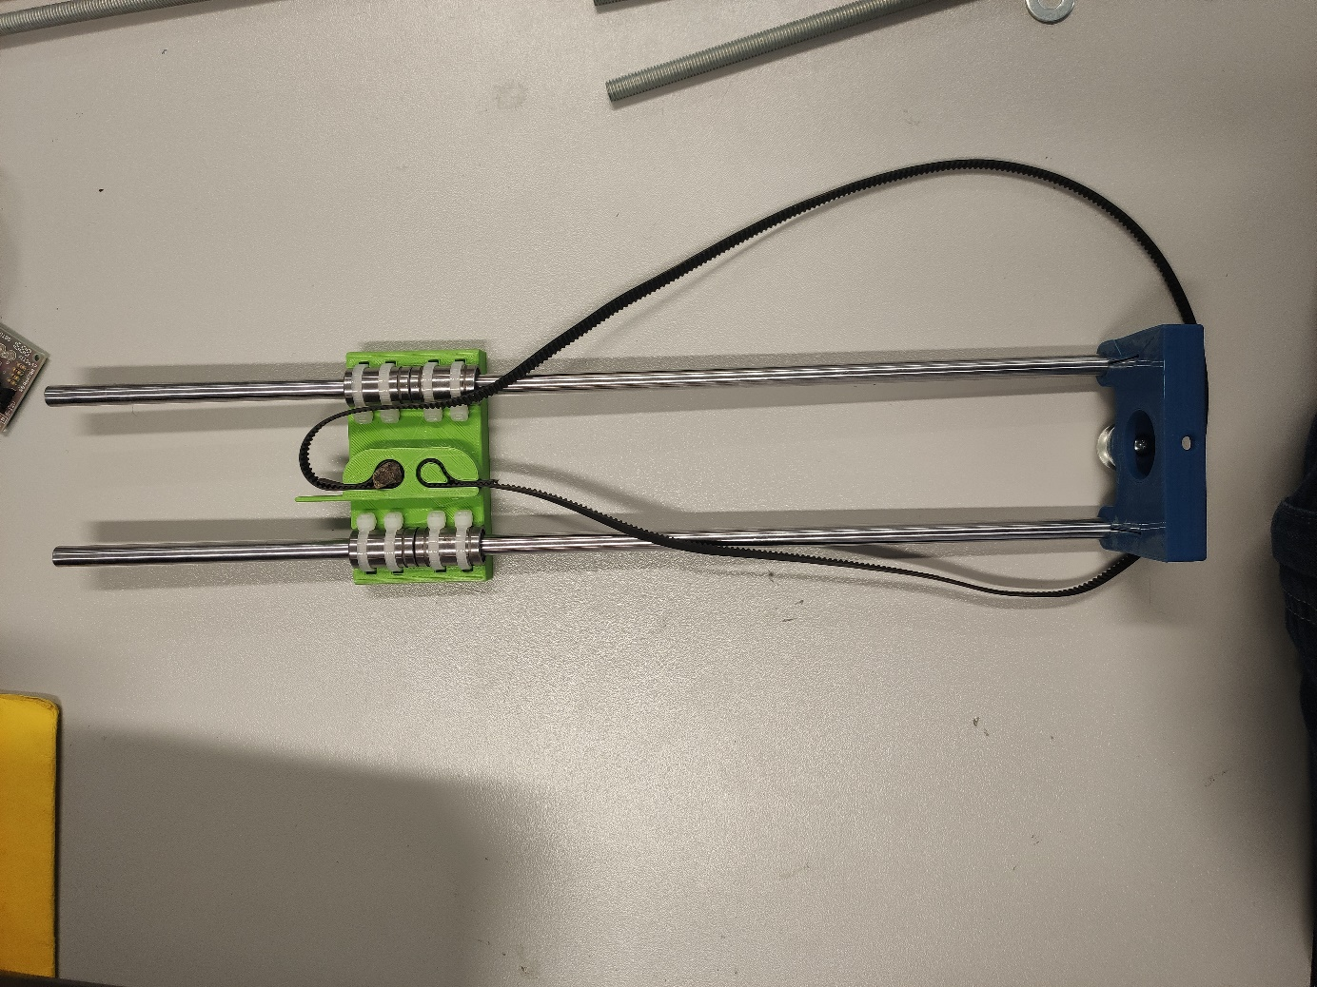

Add piece 3 in the rails.

Step 3

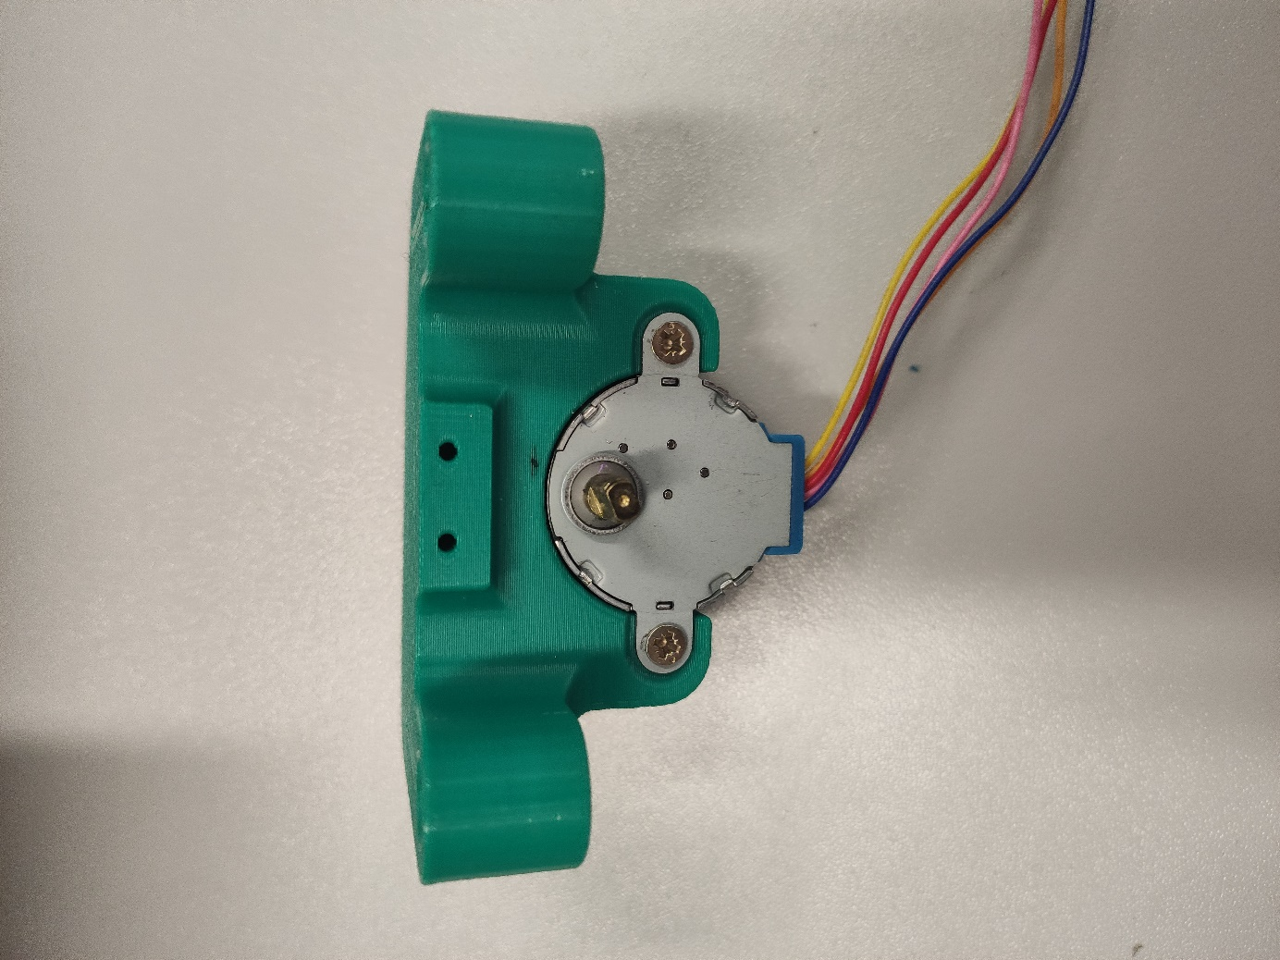

Screw the motor on the piece 1 with the screw.

Step 4

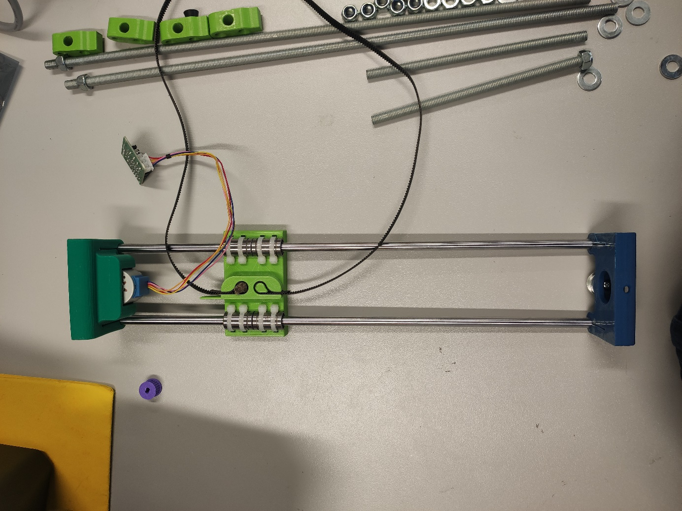 Add the piece 2 on the rails. Be careful as the notch belt need to be on the rails.

Step 5

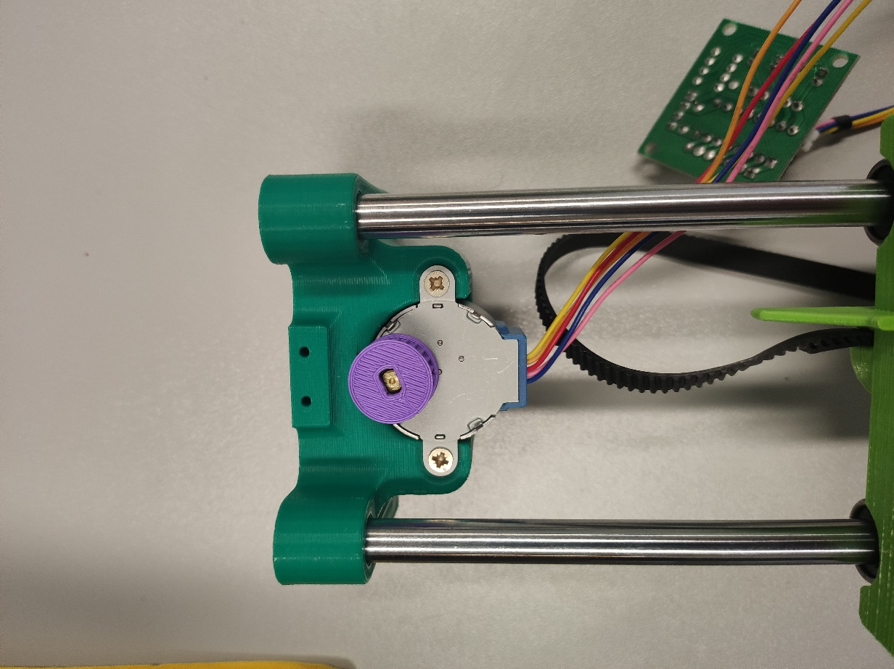

Add the notch pulley on the motor

Step 6

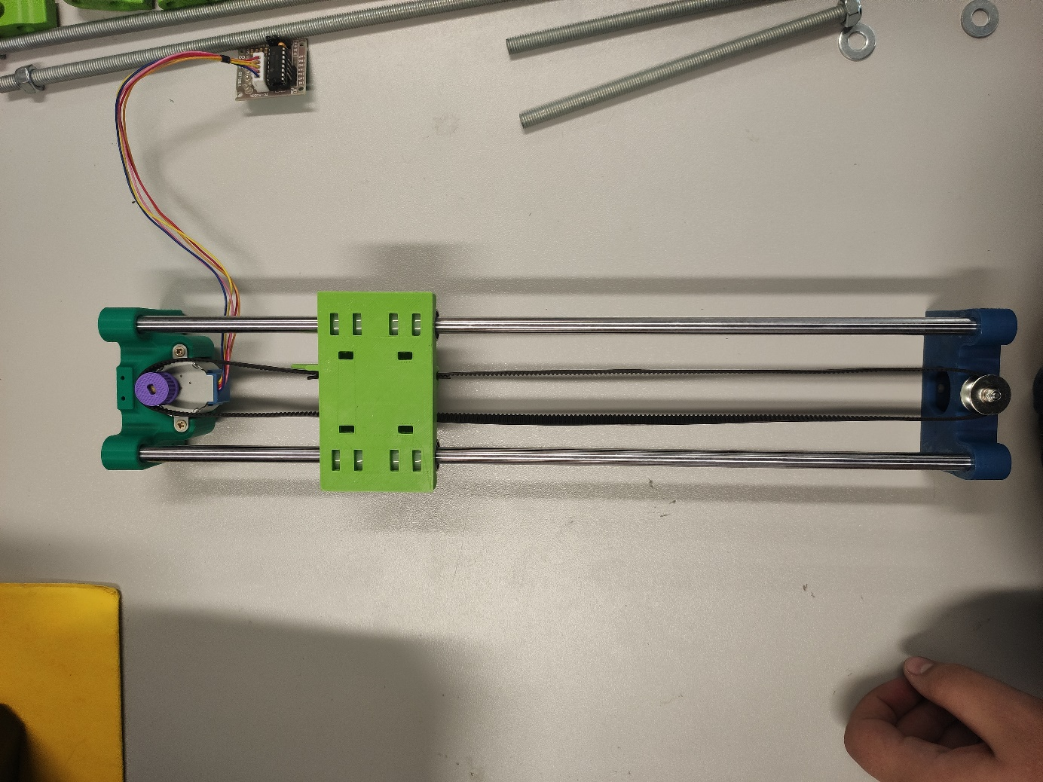

Put the notch belt on the notch pulley of the motor and the pulley of the piece 2.

Step 7

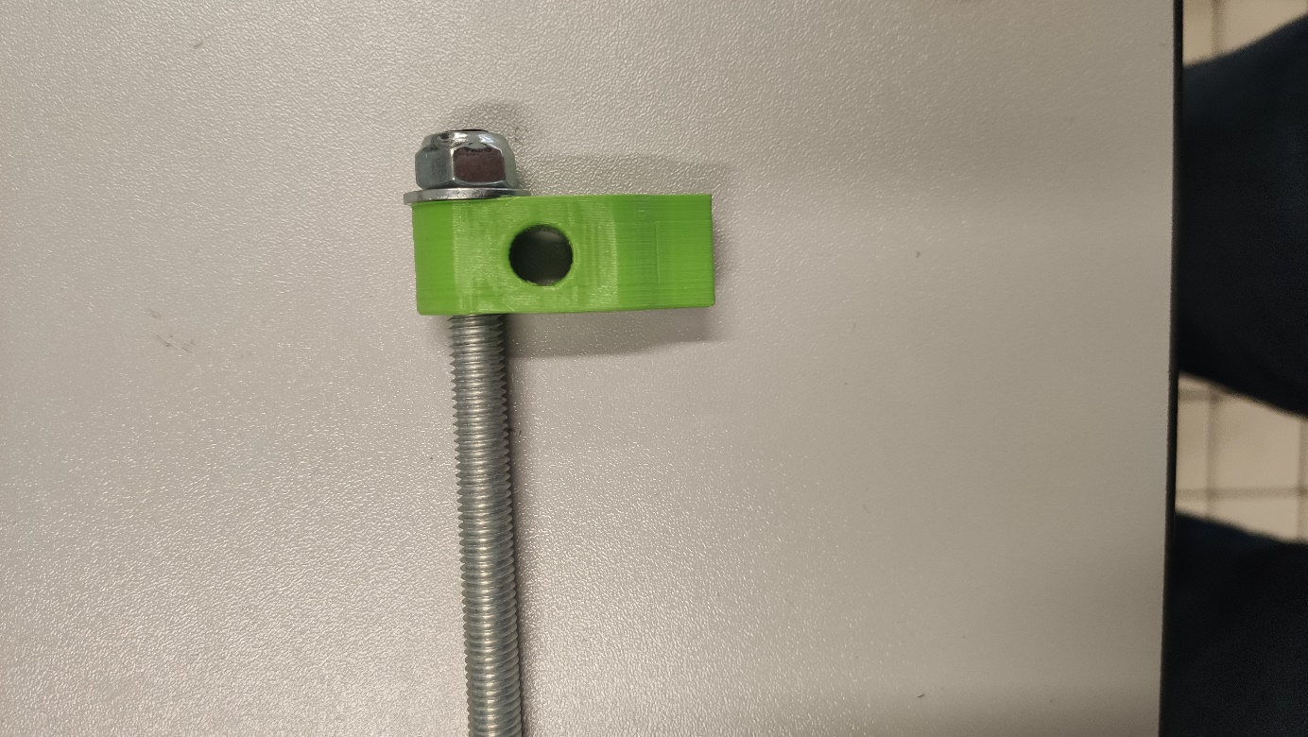

Screw the nuts on the unless screw 3and Put the washer on unless screw 3.

Put unless screw 3 into the top hole of the leg 1.

Step 8

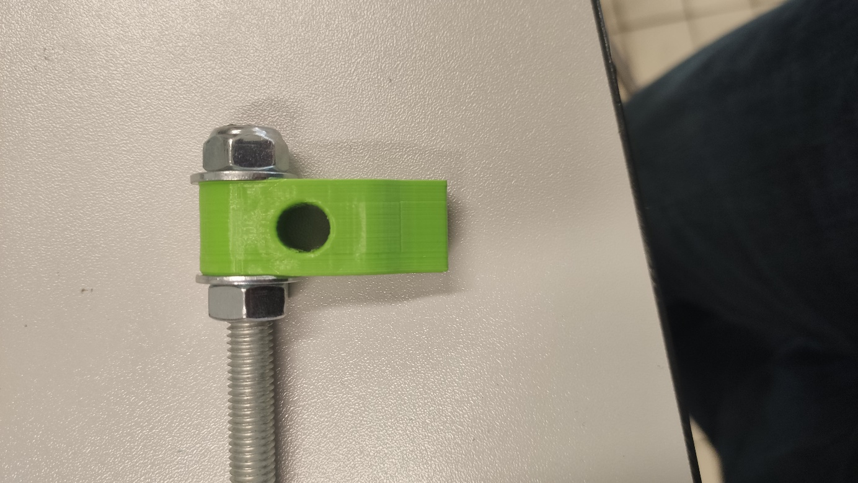

Put the washer on unless screw 3 and Screw the nuts on the unless 3 screw.

Step 9

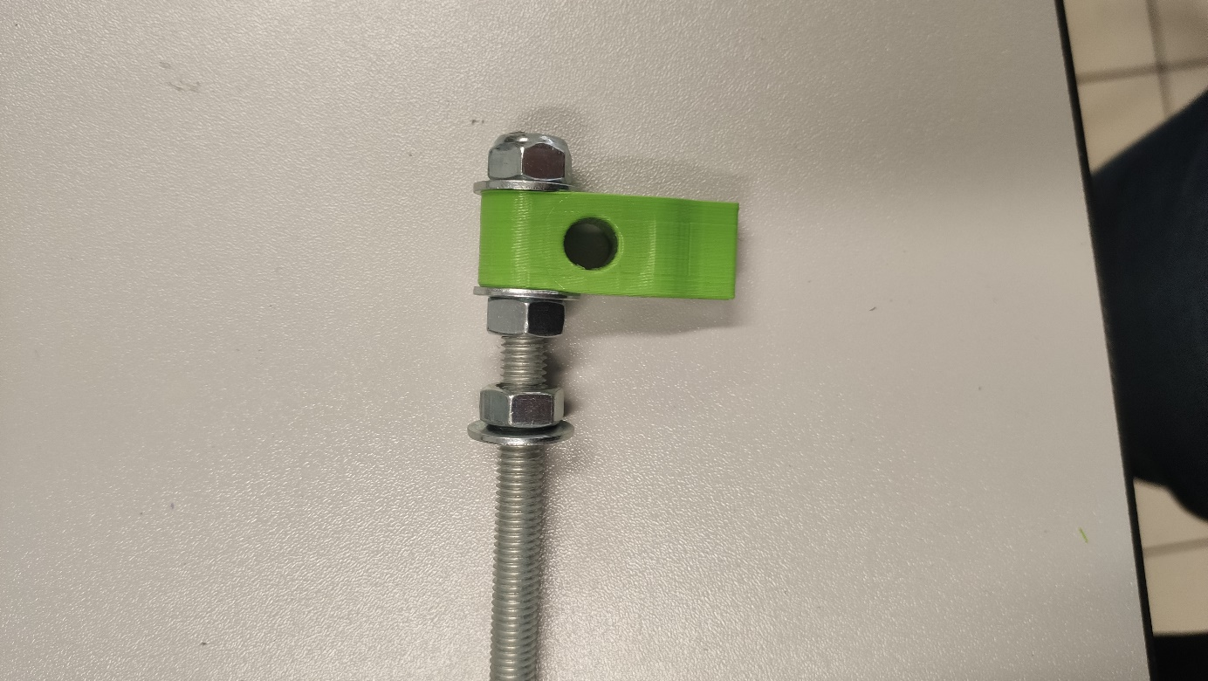

Screw the nuts on the unless screw 3 and put unless screw 3 into the top hole.

Step 10

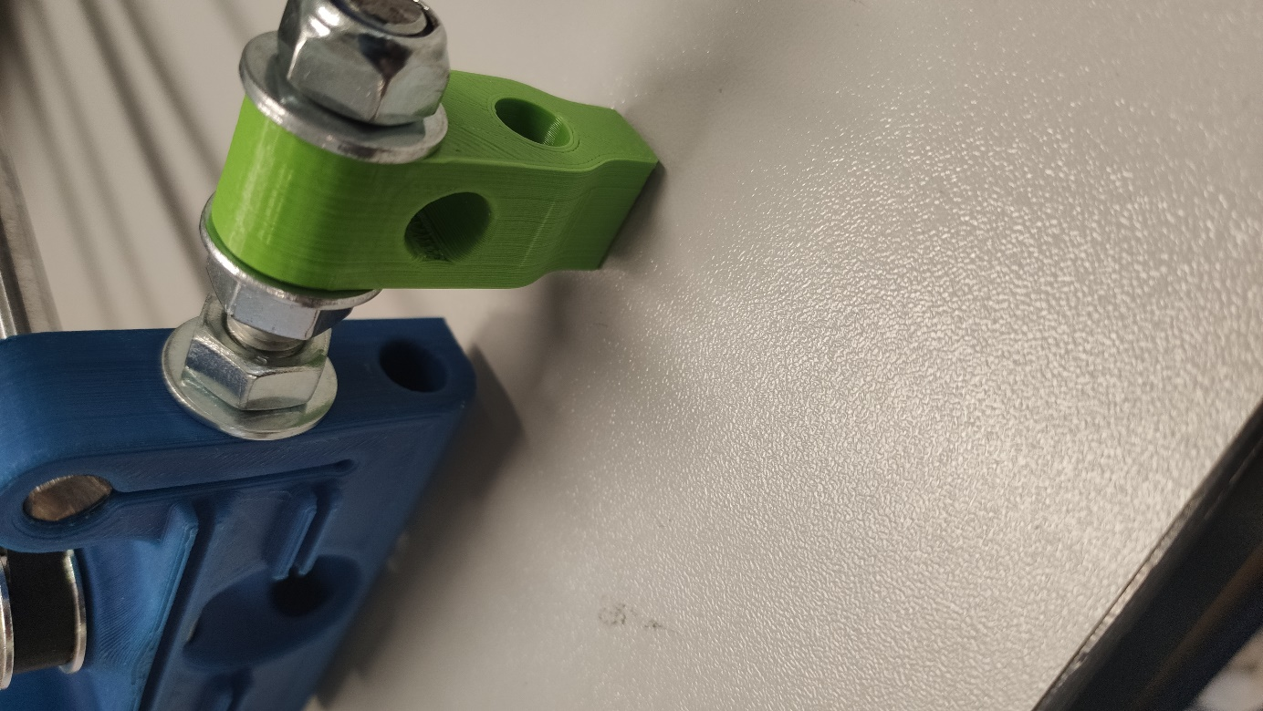

Put the endless screw 3 into the top hole of the piece 2.

Step 11

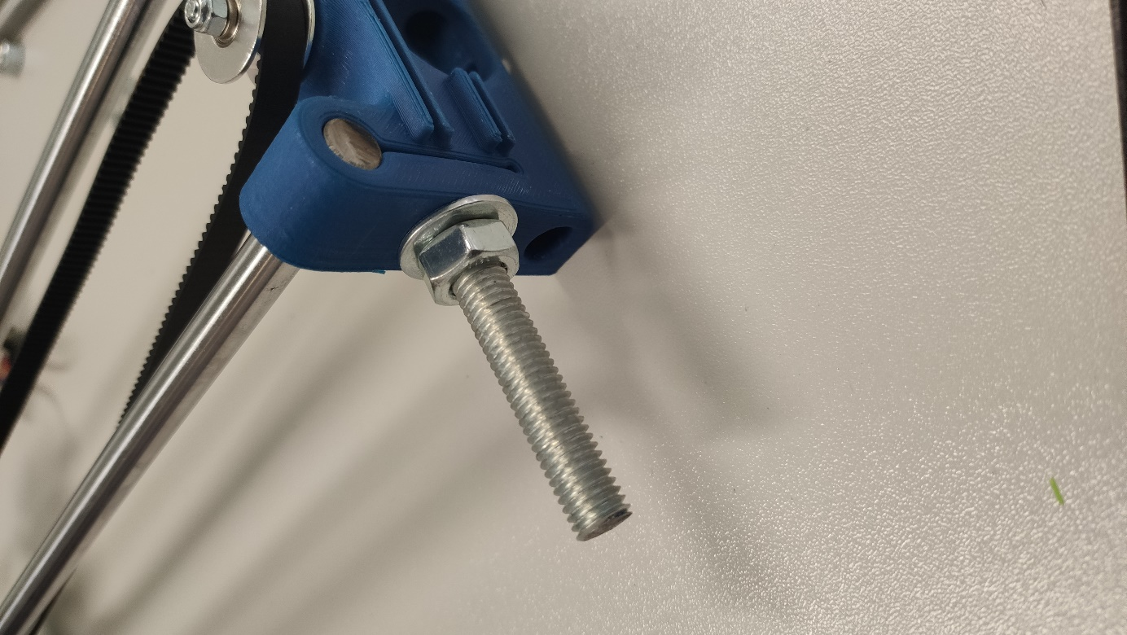

Put the washer on unless screw 3 and Screw the nuts on the unless screw 3.

Step 12

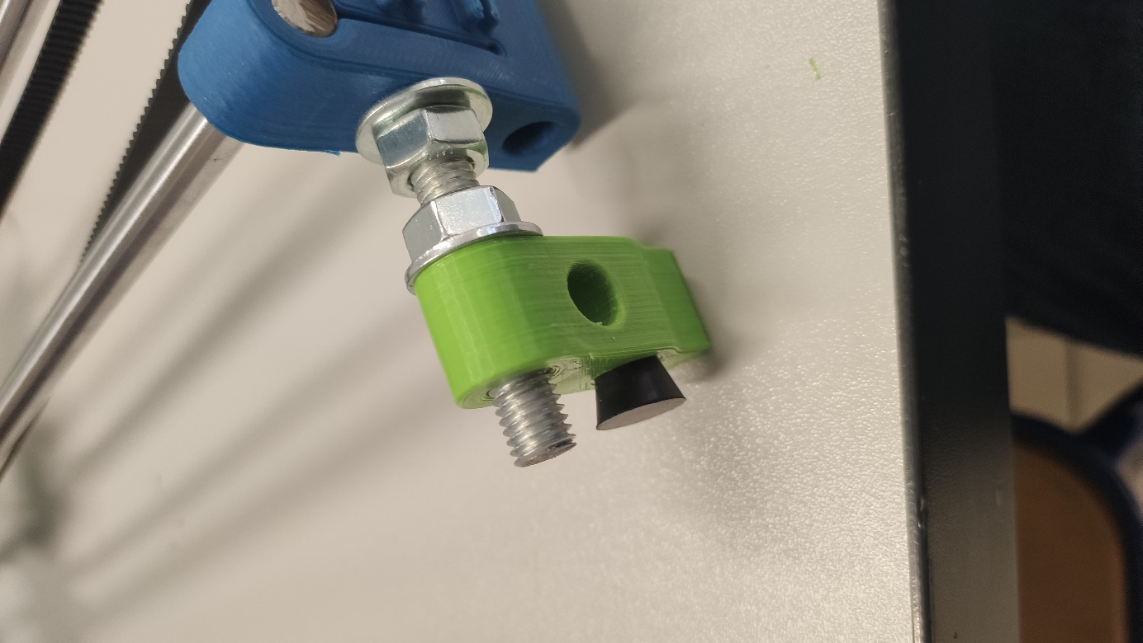

Screw the nuts on the unless screw 3 and Put the washer on unless screw 3. Put unless screw into the top hole of the leg 2.

Step 13

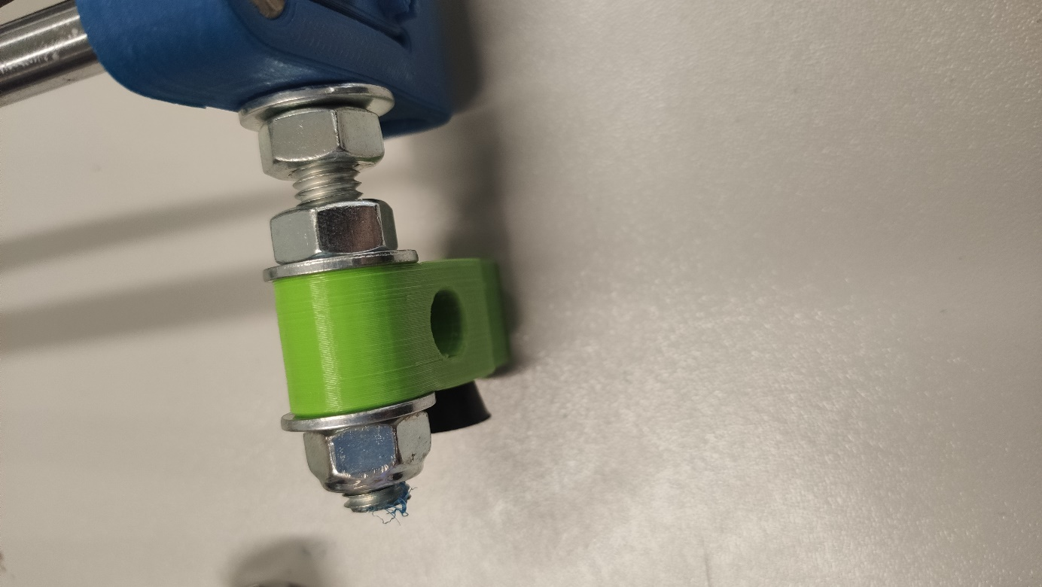

Put the washer on unless screw 3 and Screw the nuts on the unless screw 3.

Step 14

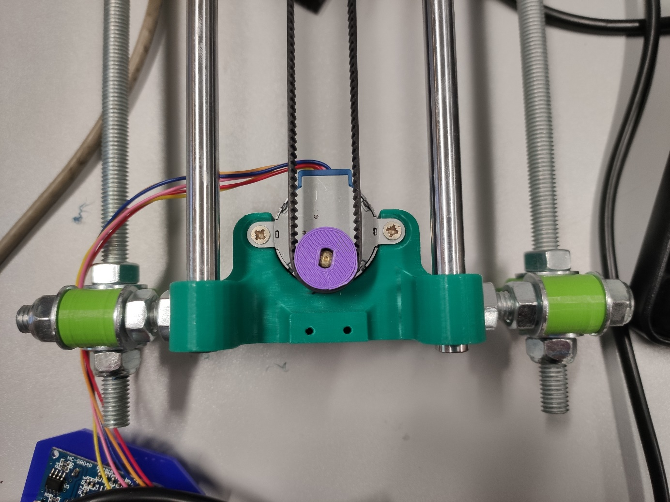Do the same on the other side and with the piece 1 and the unless screw 4

Step 15

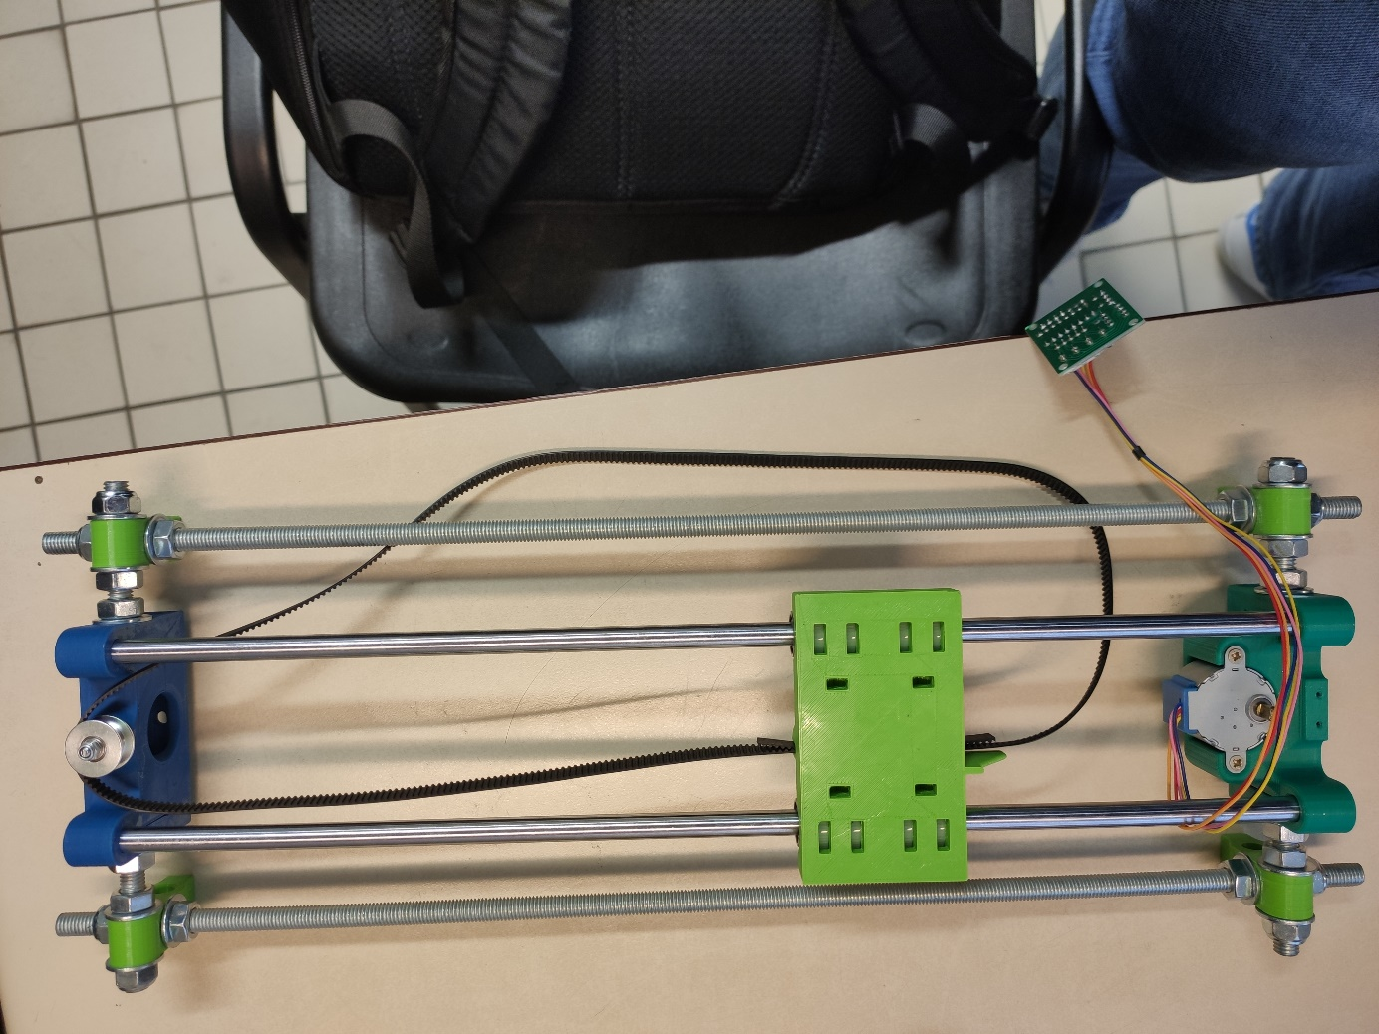

Put the endless screw 1 in a leg and put two washers each side of the endless screw 2 then do the same with the nuts

Step 16

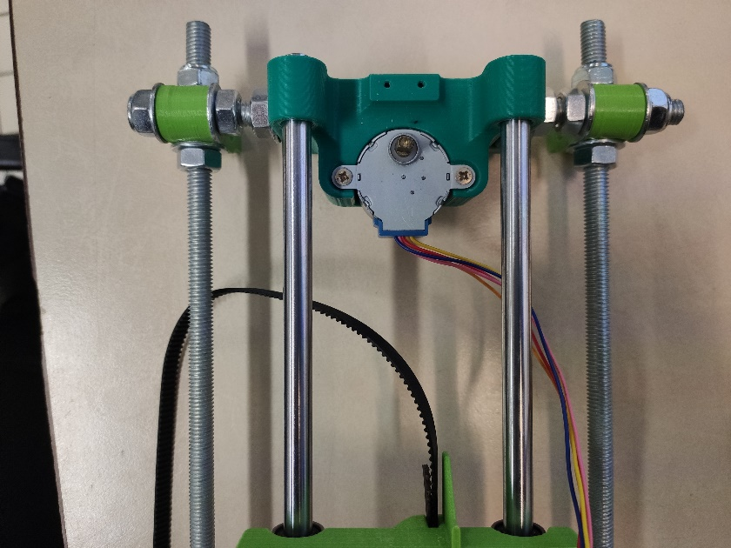

Put nuts then a washer on the endless screw 2 and put it in a leg and put a washer then a nut on the endless screw 2

Step 17



Put the endless screw 2 in a leg and put two washers each side of the endless screw 2 do the same with the nuts

Step 18



Put nuts then a washer on the endless screw 2 and put it in a leg and put a washer then a nuts on the endless screw 2

## Arduino card and components

### Components

|  |  |
| --- | --- |
| Motor 28BYJ-48-08 5 Vcc | Ultrasonic Sensor HC- SR04 |
|  |  |
| Temperature sensor DS18B20 | Patterson MS5-L |
|  |  |

### Connection to Arduino

#### Arduino Uno card

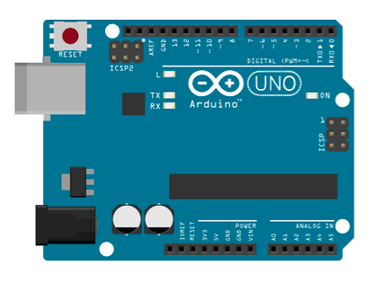

Here is the arduino that we use

### Electrical Assembly

We connected the components to the Arduino Uno card like this

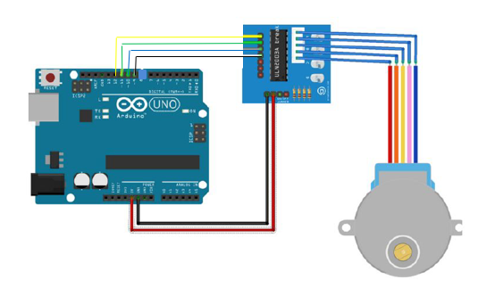Motor connection to Arduino Uno card:

-IN1 to 12 - -

-IN2 to 11 - -

-IN3 to 10 - -

-IN4 to 9 - -

-5V to 5V - -

-Ground to Ground - -

Ultrasonic sensor connection to Arduino Uno card:

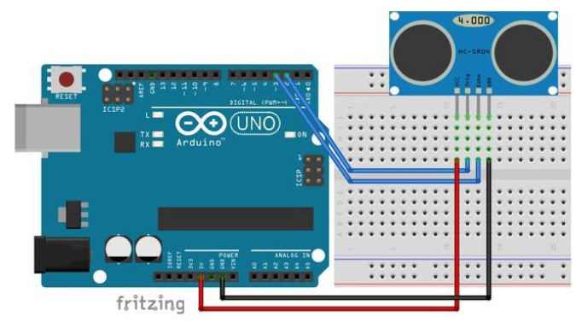

-Trig to 2 - -

-Echo to 3- -

-Gnd to 9 - -

-5V to 5V - -

Patterson MS5-L connection to Arduino uno card:

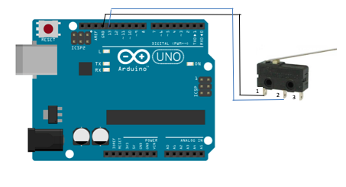

-2 to 13 - -

-1 to Gnd - -

Temperature sensor connection to Arduino Uno card:

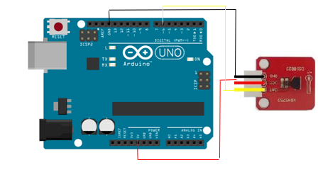

-Dat to 6 - -

-Gnd to Gnd - -

-5V to 5V - -

## Global illustration